Cucumber Framework - ******************************************************

What is Cucumber?

Cucumber is an automation testing framework which supports BDD-Behavior Driven Development.

It explains the behavior of the application functionality in the plain English text language and that language we are calling as Gherkin language.

Cucumber is developed in Ruby.

Cucumber supports – Java, C#, Python and Ruby

What is TDD and BDD?

TDD stands for Test Driven Development, in this process we design test cases in plain English language and then automation scripts are developed.

BDD stands for Behavior Driven Development, in this process we design test cases in a Gherkin language it also creates automation test scripts parallelly.

What is Gherkin language?

Gherkin is language is a business readable language which helps us to describe business behavior without going into details of implementation.

Gherkin language Annotations:

Feature

Background

Scenario

Given

When

Then

And

Scenario Outline Examples

Cucumber set up in eclipse:

#Author: your.email@your.domain.com

#Keywords Summary :

#Feature: List of scenarios.

#Scenario: Business rule through list of steps with arguments.

#Given: Some precondition step

#When: Some key actions

#Then: To observe outcomes or validation

#And,But: To enumerate more Given,When,Then steps

#Scenario Outline: List of steps for data-driven as an Examples and <placeholder>

#Examples: Container for s table

#Background: List of steps run before each of the scenarios

#""" (Doc Strings)

#| (Data Tables)

#@ (Tags/Labels):To group Scenarios

#<> (placeholder)

#""

## (Comments)

#Sample Feature Definition Template

@tag

Feature: Title of your feature

I want to use this template for my feature file

@tag1

Scenario: Title of your scenario

Given I want to write a step with precondition

And some other precondition

When I complete action

And some other action

And yet another action

Then I validate the outcomes

And check more outcomes

@tag2

Scenario Outline: Title of your scenario outline

Given I want to write a step with <name>

When I check for the <value> in step

Then I verify the <status> in step

Examples:

| name | value | status |

| name1 | 5 | success |

| name2 | 7 | Fail |

Cucumber plugs in eclipse:

1. Create a maven project

File🡪New🡪Maven Project🡪Select Create a simple project🡪Click Next🡪Enter Group Id and Artifact Id ( Ex: CucumberDemo/CucumberDemo )--.>Click Finish

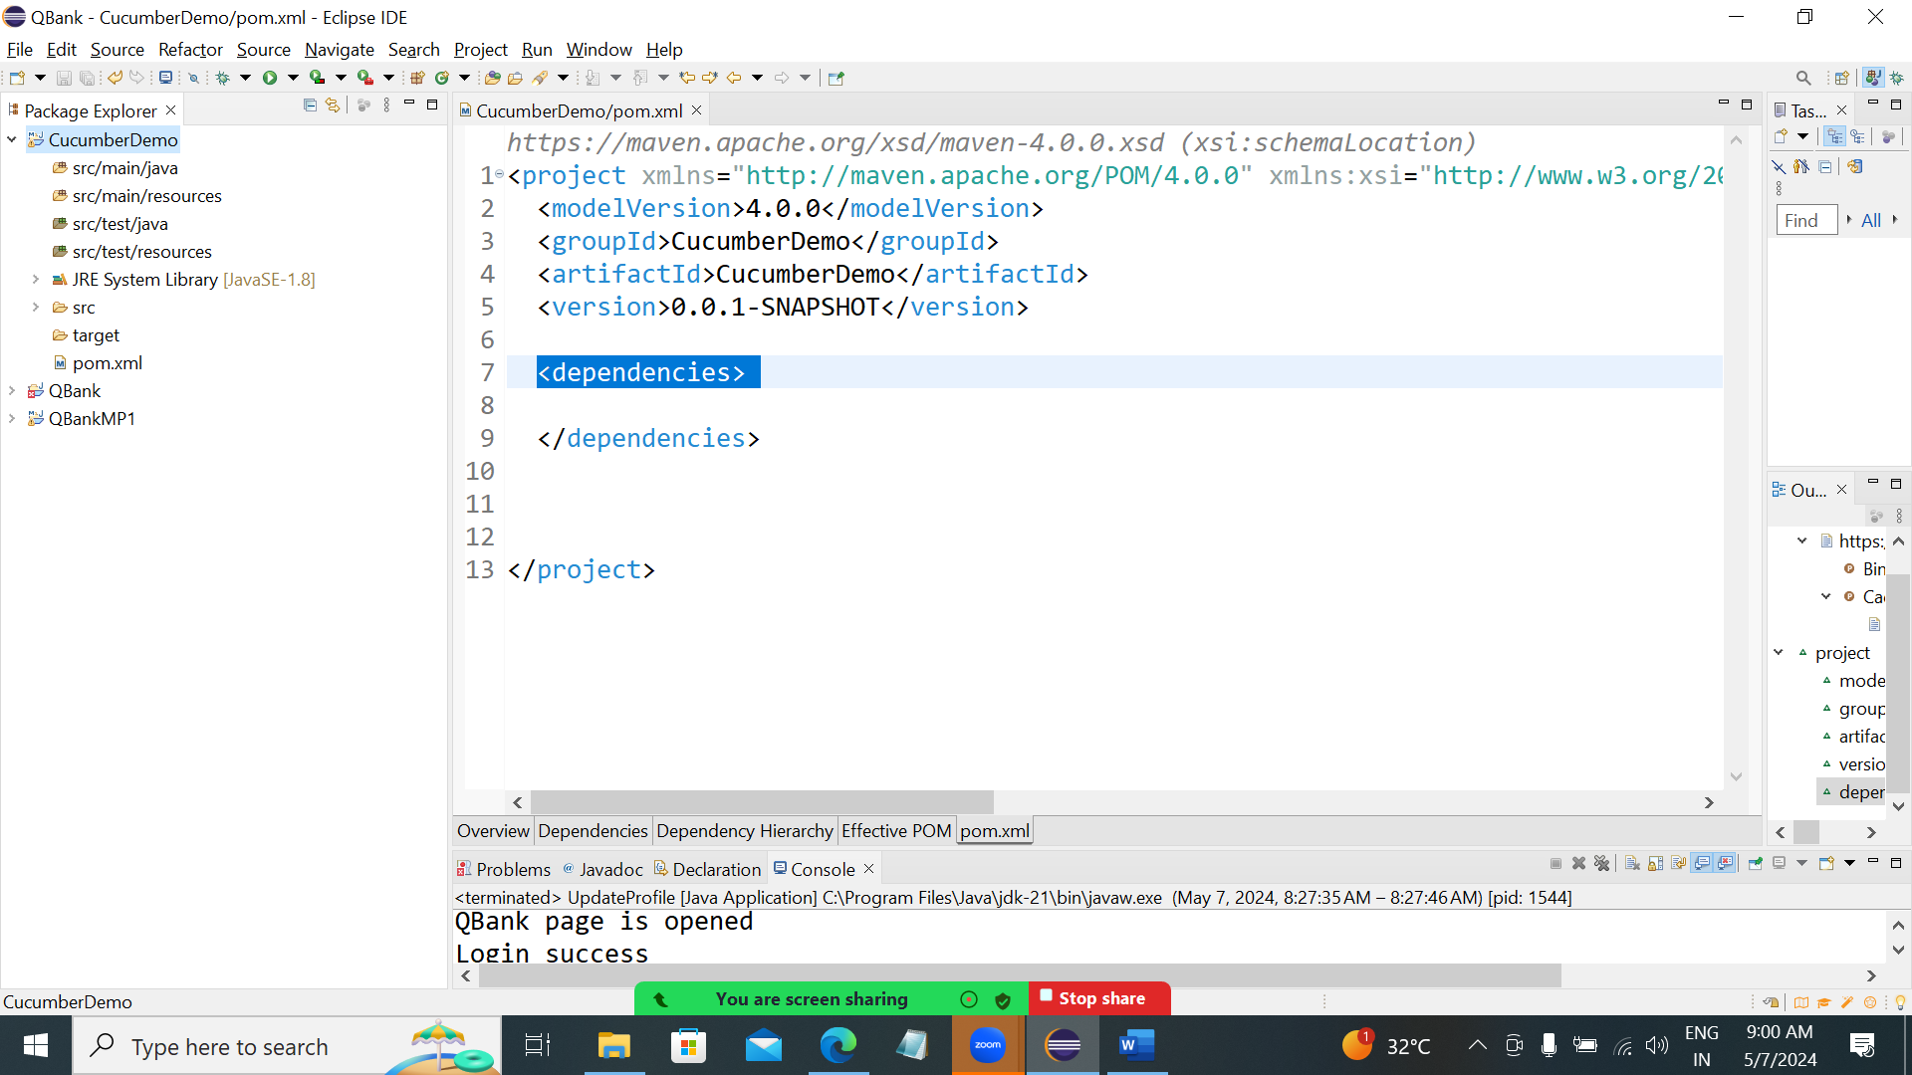

1. Open pom.xml and add <dependencies> </dependencies> tags
2. Open Maven repository url and search for Cucumber -java

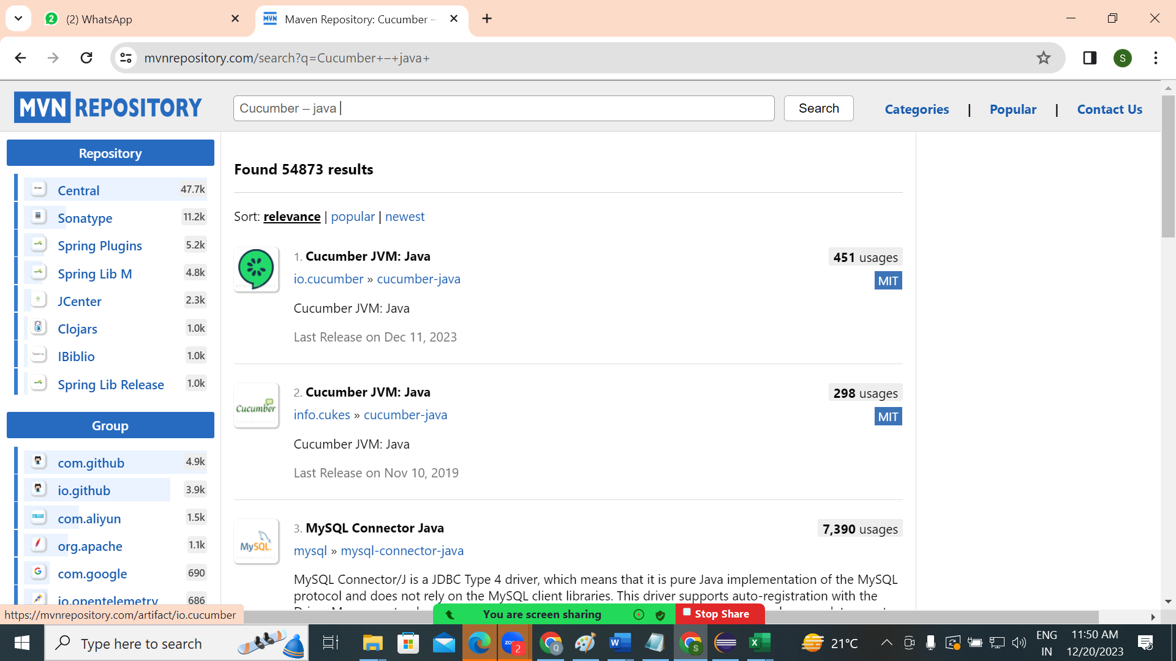



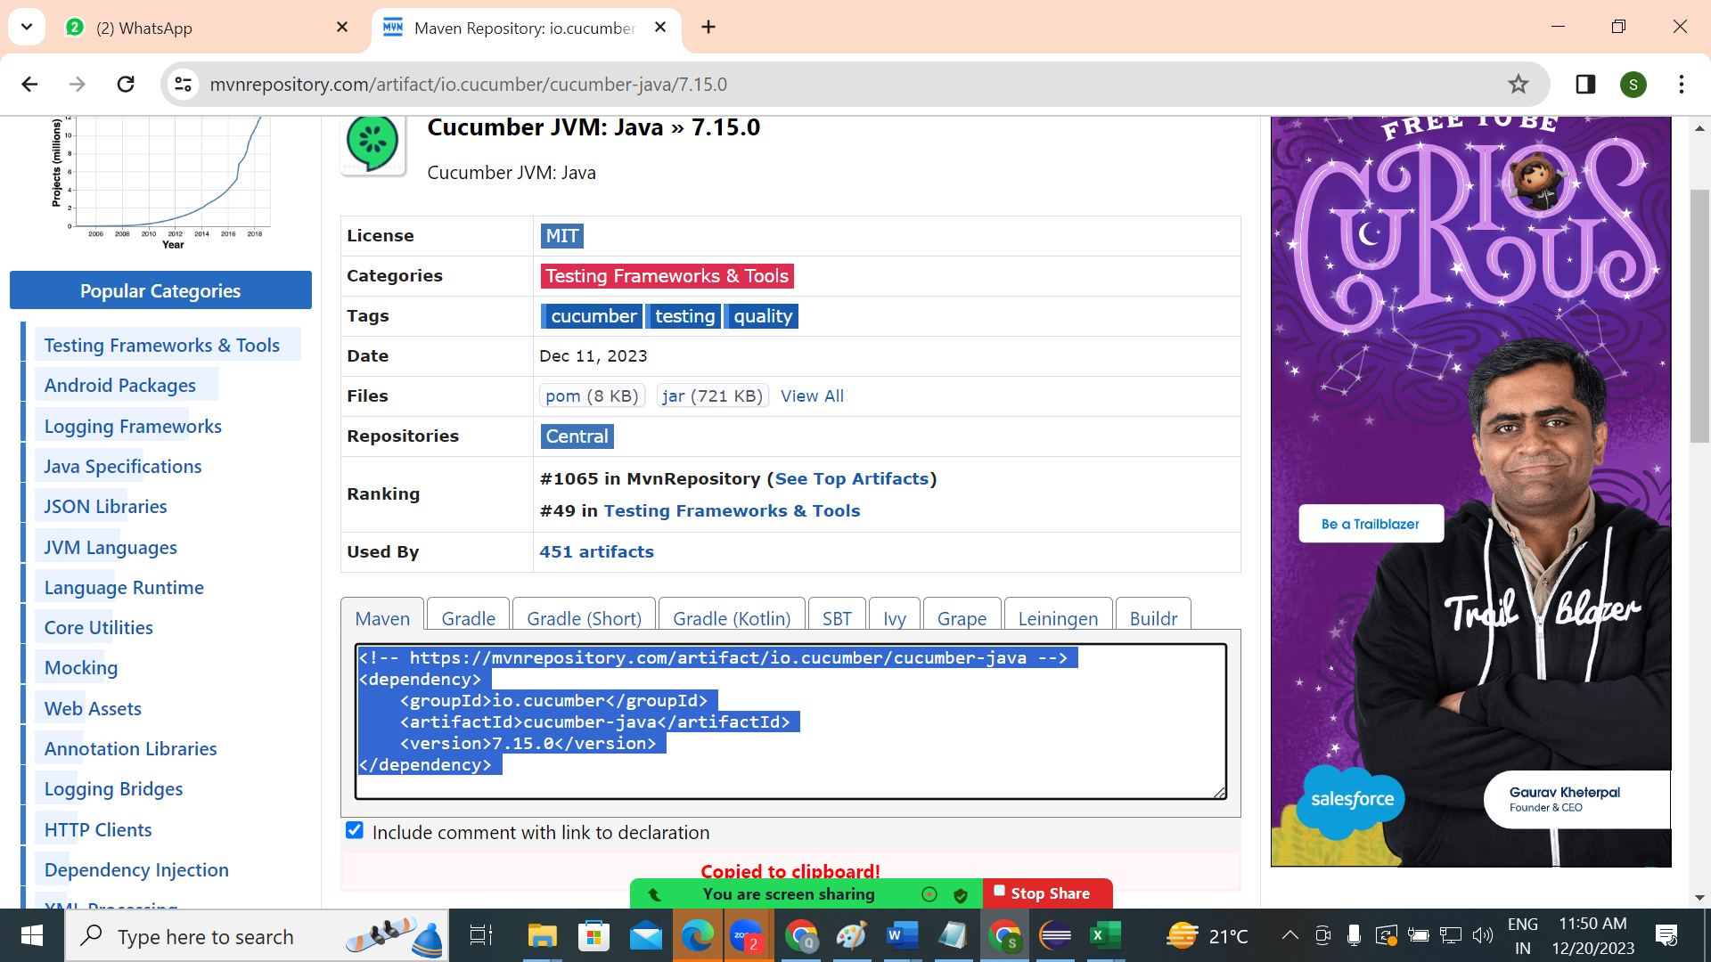

1. Add dependencies in pom

Cucumber – java ([io.cucumber](https://mvnrepository.com/artifact/io.cucumber) » [cucumber-java](https://mvnrepository.com/artifact/io.cucumber/cucumber-java))

Cucumber – junit ( [io.cucumber](https://mvnrepository.com/artifact/io.cucumber) » [cucumber-junit](https://mvnrepository.com/artifact/io.cucumber/cucumber-junit) )

Open <https://mvnrepository.com> 🡪search for cucumber-java and cucumber-jUnit

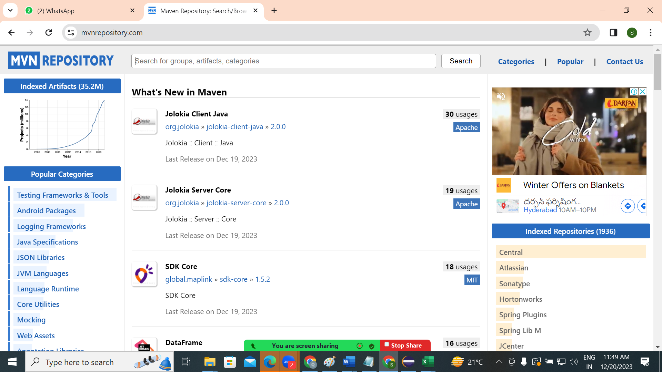

1. Create a folder to save feature files

( create a folder under project Ex: Features)

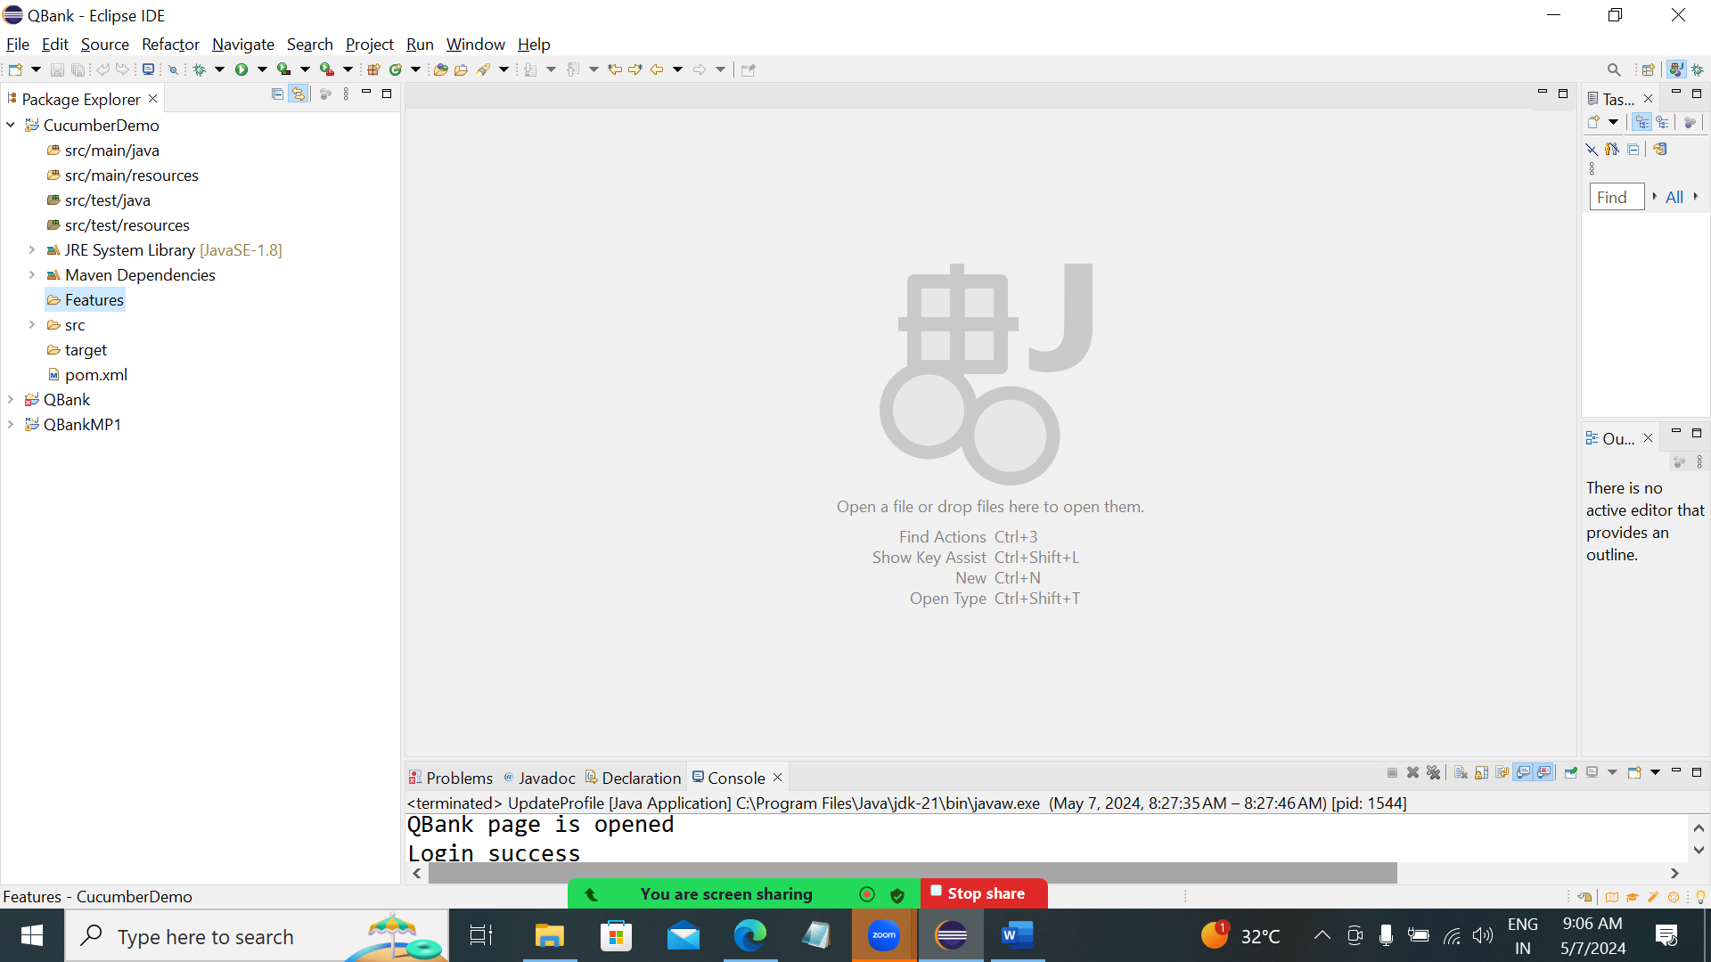

1. Create a file under above created folder with .feature extention
2. Create a gherkin language in newly created feature file
3. Now we have to execute above feature file

Create a TestRunner class in src/main/java ( enter package name : Ex: com.test )

And add the below code

**import** org.junit.runner.RunWith;

**import** io.cucumber.junit.CucumberOptions;

**import** io.cucumber.junit.Cucumber;

@RunWith(Cucumber.**class**)

@CucumberOptions(

features = "Features"

,glue= {"stepdefinition"}

)

If we are finding any errors then remove test dependencies in pom.xml

Create stepdefinition package under src/main/java

1. Run the TestRunner as JUnit test
2. Identify the errors for the methods to create
3. Create a class in stepdefinition package and copy paste the methods in errors
4. Execute TestRunner file with JUnit
5. If we have filter to execute required feature file to execute then add below code in TestRunner class

import org.junit.runner.RunWith;

import io.cucumber.junit.CucumberOptions;

import io.cucumber.junit.Cucumber;

@RunWith(Cucumber.class)

@CucumberOptions(

features = "Features",

glue= "stepdefinition",

tags= "@Regression"

)

Add the given tag @Regression in required feature file

Creating a new feature file ( new script )

Right click on required folder 🡪New🡪File🡪Enter the file name with .feature extn

🡪click ok

Sample feature file:

@Regression

Feature: TS01_OHRM_Login_Lgout

Scenario: Open OHRM page

When user opens "Chrome" browser

When user given OHRM url

Then OHRM page opens

Scenario: Login OHRM

When user eners login details and click login button

Then OHRM welcome page opens

Scenario: Logout OHRM

Execuitng feature file:

Right click on TestRunner.class file🡪Run as 🡪JUnit

Scenario outline:

This is used to execute a scenario for required number of times with given data

Syntax:

Scenario Outline: dsiplay a message

When user display a message "<message>"

Examples:

| message |

| Master |

| Amex |

| Visa |

| Amex |

FAQS on Cucumber?

1. What is cucumber framework?

Cucumber framework is a automation framework which supports BDD process.

1. What is BDD process?
2. Diff between TDD and BDD?
3. How do you configure Cucumber in your company for your project?

Already it is configured in my project and I am using, but I can explain :

1. What is Maven project?
2. What is the diff between Maven and java project?
3. What is dependency in Maven pom.xml?
4. How do you configure Selenium, POI, or other libraries in Maven?
5. What is Gherkin language?
6. What are the Gherkin keywords?
7. How do you execute your feature files?

To execute a single feature, right click on required required file and select run as feature

If we want to execute multiple features then we run from TestRunner class

1. What is TestRunner program?

TestRunner is a class and it handles the execution of multiple feature

1. How your TestRunner program execute required scripts.
2. @RunWith(Cucumber.**class**)
3. @CucumberOptions(
4. features = "Features",
5. glue= "stepdefinition",
6. tags= "@Regression"
7. )
8. What is the difference between Scenario and Scenario outline
9. How do you parameterize your steps